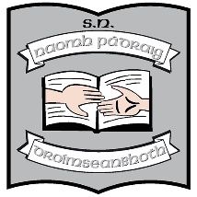
St. Patrick’s National School
Parents’ Association
Annual General Meeting
Minutes from Meeting – 21st January 2025

- Welcome from Chairperson, Kevin Blessing.

- Chairperson’s Report read by Kevin.

- Principal’s Report read by Ruth McLoughlin.

- Treasurer’s Report read by Edel Spark.

- AOB
  - A general discussion ensued on a number of issues including: publishing of minutes, election of new member of Parents’ Association and hot lunches.

- Paul Martin thanked Kevin for his contribution as Chairperson.
The meeting came to an end.

