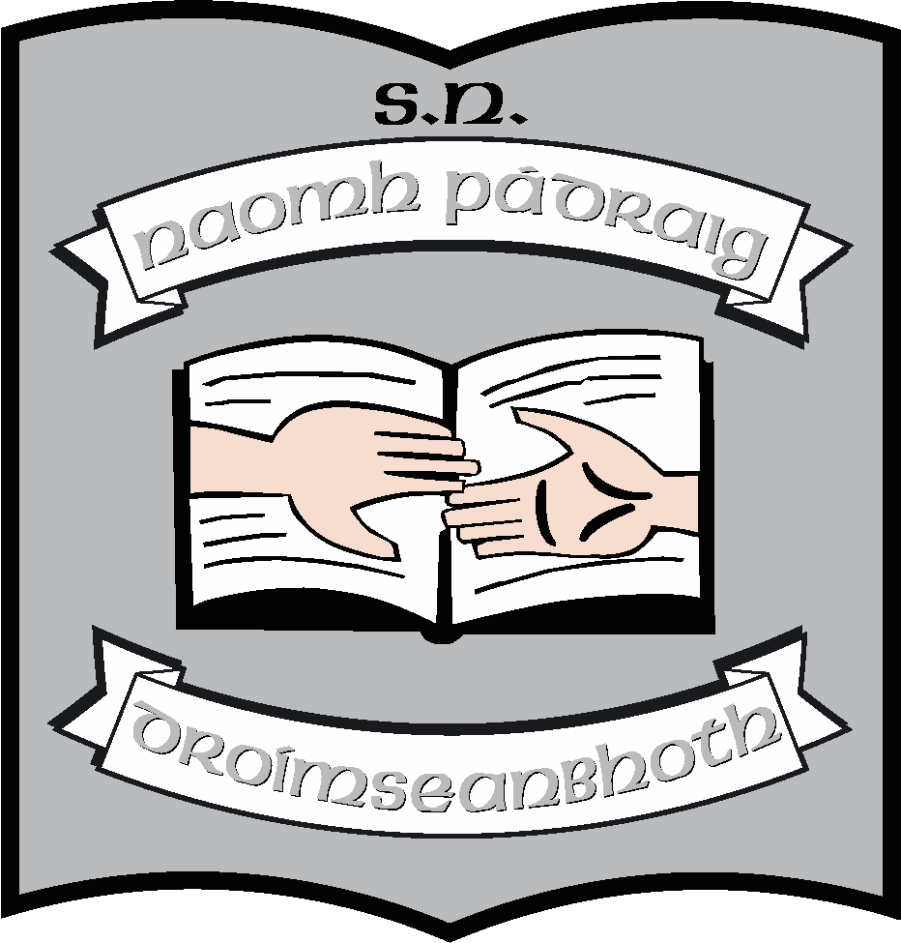 **St. Patrick’s NS;**

**Admission Notice**

***(in respect to Admission for 2025 – 2026)***

**Admission Policy and Application Form**

A copy of the school’s **Admission Policy** and the **Application Form for Admission** for the 2025/26 school year is available as follows:

To download at: https://stpatricksnsdrumshanbo.ie/blog/enrolment-information/

On request:

Email: [**stpatricksns@stpatricksnsdrumshanbo.ie**](mailto:stpatricksns@stpatricksnsdrumshanbo.ie)or

write to: **St. Patrick’s NS, Drumshanbo, Co. Leitrim. N41 PY61.**

**PART 1 - Admissions to the 2025 - 2026 school year**

**Application and Decision Dates for admission to 2025 - 2026**

The following are the dates applicable for admission to Junior Infants:

|  |  |
| --- | --- |
| The school will commence accepting applications for admission on | **07/10/2024** |
| The school shall cease accepting applications for admission on | **10/01/2025** |
| The date by which applicants will be notified of the decision on their application is | **03/02/2025** |
| The period within which applicants must confirm acceptance of an offer of admission is | **14/02/2025** |

**Note: the school will consider and issue decisions on late applications in accordance with the school’s admission policy.**

**Special Class Application and Decision Dates for admission to St. Patricks’ NS**

We will have four places available in our special classes and therefore will accept enrolment applications for 2025/26. In the event of the number of children seeking enrolment in the Autism classes exceeding the number of places available, the criteria stated in the school’s Autism Admission Policy will apply.

**Failure to accept an offer within the prescribed period above may result in the offer being withdrawn.**

**Number of places being made available in 2025- 2026**

|  |  |
| --- | --- |
| The number of places being made available in Junior Infants is | **30** |
| The number of places being made available in the Autism classes catering for children with Autism is | **4** |
| Number of names placed on waiting list for Autism Classes for the school year 2025-2026 is | **0** |

**PART 2 - Admissions to the 2023 - 2024 school year**

In respect of the 2023 – 2024 school year, the total number of applications for admission received by the school was as follows:

|  |  |
| --- | --- |
| **Breakdown of places allocated for the 2023 - 2024 school year:** | |
| Number of places available: | 51 |
| Number of applications received: | 38 |
| Number of Offers made and accepted under each criteria: | 36 – mainstream  0 – special classes |
| Total number of offers made | 36 |
| Number of names placed on waiting list for mainstream for the school year concerned. | 2 |
| Number of names placed on waiting list for Special Classes for the school year concerned. | 10 |

**PART 3 - Admissions to the 2024 - 2025 school year**

In respect of the 2024 - 2025 school year, the total number of applications for admission received by the school was as follows:

|  |  |
| --- | --- |
| **Breakdown of places allocated for the 2024 - 2025 school year:** | |
| Number of places available: | 44 |
| Number of applications received: | 36 |
| Number of Offers made and accepted under each criteria: | 30 – mainstream  6 – special classes |
| Total number of offers made | 36 |
| Number of names placed on waiting list for mainstream for the school year concerned. | 0 |
| Number of names placed on waiting list for Special Classes for the school year concerned. | 0 |

Date: 07/10/2024