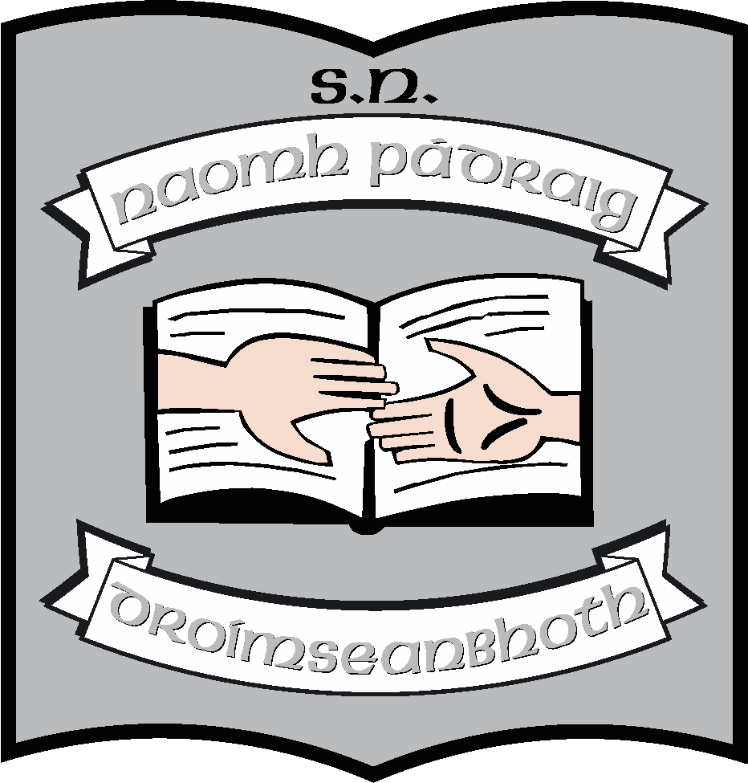

**St. Patrick’s NS: Staffing: 2024 - 2025**

|  |  |
| --- | --- |
| **Principal** | Ruth McLoughlin |
| **Deputy Principal** | Orla Walsh |
| **6th Class** | Edel Lane (Anna Corcoran for team teaching) |
| **5th Class (A)** | Jeannette Reynolds (AP2) / Stephanie Reynolds (Job-share) |
| **5th Class (B)** | Clare McCabe (AP2)/Maria McGoldrick |
| **4th Class** | Ciara Tiernan (Anna Corcoran for team teaching) |
| **3rd Class** | Áine Smith |
| **2nd Class** | Maureen McNamara |
| **1st Class** | Martina Duignan |
| **Senior infants** | Michelle Kelly |
| **Junior Infants** | Sinéad Rogers |
| **Autism Class** | Louise Brennan (AP2) |
| **Autism Class** | Rachel Noone |
| **Autism Class** | Emma Earley |
| **SNAs** | Donna Flynn  Julie Durkin  Deborah Kehoe  Samantha Cullen  Sinéad Dolan  Ann Flood  Olive Murphy  Davinya Sheehan  Sharon McGovern  Caolann Scollan  Sinéad Dolan  Dylan Easterbrook |
| **Support Teaching Team** | Orla Walsh (DP)  Regina McLoughlin  John Molloy  Niall Craig (EAL)  Louise Henry (Visiting SET) |
| **Secretary** | Caroline Flynn |
| **Cleaner** | Raymond McGovern |
| **Caretakers** | Maurice Cullen |
| **Bus escorts** | Caroline Flynn  Cerenna Reynolds  Kyna Duignan  Colleen Blessing  Aoife Lupton  Izabela Szajna |