St. Patrick’s N.S.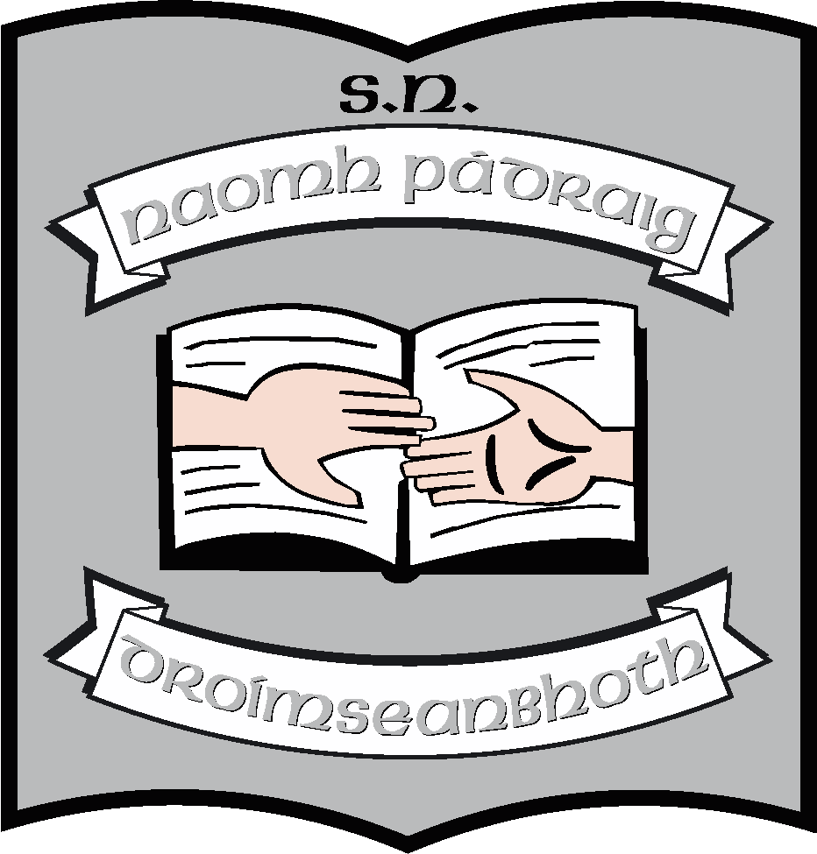

Drumshanbo,

Co. Leitrim.

Roll No: 19423J

**Child Protection Policy**

**Reviewed:** September 2024

**Ratified:**

**Annual review:** September every year

- Risk Assessment

- Checklist for BOM

**Full review:** As requested by Government

**Appendix A:** Prevention, Procedures & Practices related to Child Protection

**Appendix B:** School Self Report on Child Protection Policy

**St. Patrick’s National School**

**Child Protection Policy 2024**

The Board of Management of St. Patrick’s NS recognises that child protection and welfare considerations permeate all aspects of school life and must be reflected in all aspects of the school’s policies, practices and activities. Accordingly, in accordance with the requirements of the Department of Education and Skills’ **Child Protection Procedures for Primary and Post Primary Schools**, the Board of Management of St. Patrick’s National School has agreed the following child protection policy:

1. The Board of Management has adopted and will implement fully and without modification the Department’s Child Protection Procedures for Primary and Post Primary Schools as part of this overall child protection policy.
2. The Designated Liaison Person **(DLP) is Ruth McLoughlin**
3. The Deputy Designated Liaison Person **(Deputy DLP) Orla Walsh**
4. In its policies, practices and activities, St. Patrick’s N.S. will adhere to the following principles of best practice in child protection and welfare:

The school will

* Recognise that the protection and welfare of children is of paramount importance, regardless of all other considerations.
* Fully co-operate with the relevant statutory authorities in relation to child protection and welfare matters.
* Adopt safe practices to minimise the possibility of harm or accidents happening to children and protect workers from the necessity to take unnecessary risks that may leave themselves open to accusations of abuse or neglect.
* Develop a practice of openness with parents and encourage parental involvement in the education of their children.
* Fully respect confidentiality requirements in dealing with child protection matters.

The school will also adhere to the above principles in relation to anyone in the school community with a special vulnerability.

1. The Board has ensured that the necessary policies, protocols and practices as appropriate are in place. (SEE ATTACHED APPENDIX).
2. This policy has been made available to school personnel and the Parent’s Association and is readily accessible to parents and all stakeholders on our school website. A copy of this policy will be made available to the Department and the patron if requested.
3. This policy was adopted by the Board of Management on 26/09/2023.

**Signed**: Martin McGowan

**Chairperson of BOM Date**

**Signed:** Ruth McLoughlin

**Principal Date**

**Date of next review**: **September 2025**

**Appendix A**

The staff and management of St. Patrick’s NShave agreed this policy in line with the current recommendations and guidelines relating to child abuse prevention and child protection guidelines.

This appendix addresses the responsibilities of the school in the followings areas:

1. Prevention – curriculum provision
2. Procedures - procedures for dealing with concerns / disclosures
3. Practice - best practice in child protection

An individual copy of this policy document and the appended section from the Department of Education and Skills Child Protection Procedures will be made available to all staff.

It is incumbent on all staff to familiarize themselves with ‘Children First’ and the DES child protection guidelines and procedures.

1. **Prevention**

* The Stay Safe programme is the primary resource used in this school to provide education for children on abuse prevention. The programme is taught in all classes as part of the schools’ SPHE curriculum under the strand unit Safety and Protection.
* The formal lessons of the programme will be taught in their entirety every year in accordance with our most recent SPHE policy. Staff will make every effort to ensure that the messages of the programme are reinforced whenever possible.
* Lessons from the Walk Tall Programme and RSE classroom resources are also used.
* The Weaving Wellbeing Programme was introduced into the school in 2018/19 and two teachers, Jeannette Reynolds and Regina McLoughlin received training in it. It is now taught from 2nd – 6th classes.
* Teachers are encouraged to teach class appropriate lessons on safe use of Internet and to celebrate Internet Safety Day in February each year.
* Every two years we invite a guest speaker in to talk to all stakeholders regarding internet safety and safety online.

1. **Procedures**

All staff and volunteers in the school will follow the recommendations for reporting concerns or disclosures as outlined in the DES Child Protection Procedures’ 2011.

**Maintaining records**

When child abuse is suspected, it is essential to have a record of all the information available.

Personnel should note carefully what they have observed and when they observed it. Signs of physical injury should be described in detail and, if appropriate, sketched. Any comment by the child concerned, or by any other person, about how an injury occurred should be recorded, preferably quoting words actually used, as soon as possible after the comment has been made.

All records so created should be regarded as highly confidential and retained in a secure location by the Designated Liaison Person. A record book for this specific purpose will be maintained in the office of the school.

The staff and management of this school have agreed:

* All concerns/ disclosures involving child protection/child welfare issues will be reported in the first instance to the DLP (deputy DLP where appropriate).
* Each report to the DLP will be dated and signed by the person making that report.
* A strict adherence to maintaining confidentiality – information regarding concerns or disclosures of abuse should only be given on a ‘need to know’ basis.

1. **Practice**

The school will implement the statutory requirements for Garda Vetting as laid out in Circular 31/16. (Added October 2016)

The staff and BOM of this school have identified the following as areas of specific concern in relation to Child Protection. Following discussion and consultation, the staff and BOM have agreed that the following practices be adopted:

* Physical contact between school personnel and the child should always be in response to the needs of the child and not the needs of the adult

When physical contact may be used to comfort, reassure or assist a child, the following should be factors in determining its appropriateness:

* It is acceptable to the child
* It is open and not secretive
* The age and development stage of the child

School personnel should avoid doing anything of a personal nature for children that they can do themselves.

School personnel should never engage in or allow:

* The use of inappropriate language or behaviours
* Physical punishment of any kind
* Sexually provocative games or suggestive comments about or to a child
* The use of sexually explicit or pornographic material

All media products (Phones, ipads CDs, DVDs etc.) should be checked for their appropriateness with regard to age and suitability.

**Visitors/Guest Speakers**

Appropriately appointed and screened visiting teachers of varying disciplines, and HSE/NEPS personnel engaged to perform specific duties, will be left work with a class alone when this is deemed necessary.

Other visitors/guest speakers should never be left alone with pupils. The school (Principal/ teachers) has a responsibility to check out the credentials of the visitor/guest speaker and to ensure that the material in use is appropriate.

**Children with specific toileting/intimate care needs**

An Intimate Care policy is in place to clarify correct procedures for children with intimate care needs.

**Toileting Accidents**

Clean underwear and suitable clothing will be kept in the school so that is a pupil has an ‘accident’ of this nature, they will in the first instance be offered fresh clothing into which they can change.

If the pupil for whatever reason cannot clean or change themselves and the parents/guardians cannot be contacted, the child will be assisted by members of staff familiar to the child. In all such situations, two members of staff should be present. A record of all such incidents will be kept and Principal and parents be notified.

**Accidents**

While every precaution will be taken under our Health and Safety Statement to ensure the safety of children, we realise that accidents will happen. Accidents will be noted in our incident book and will be as part of Health and Safety.

**One-to-one Teaching**

* It is the policy in this school that one-to-one teaching can sometimes be in the best interest of the child.
* Every effort will be made to ensure that this teaching takes place in an open environment.
* Parents of children who are to be involved in one-to-one teaching will be informed and their agreement sought.
* Work being carried out by Special Needs Assistants will be carried out under the direction of the class teacher in an open environment.

**Changing for Games/PE/Swimming**

Pupils will be encouraged to dress and undress themselves for Games/PE/Swimming as far as possible. Where assistance is needed, this will be done in the communal area and with the consent of parents. Under no circumstances will members of staff/volunteers be expected to or allowed to dress/undress a child unsupervised in a cubicle/private area. In such situations where privacy is required, the parents/guardians of the child will be asked to assist the child. There must be adequate supervision of pupils at all times.

In respect to children in the Autism Class, no child will be alone with an adult – there will always be another child present and a supporting adult on hand.

While every effort will be made to adhere to best practice as agreed and outlined above, in the event of an emergency where this is not possible or practicable, a full record of the incident should be made and reported to the Principal and parents.

**Behaviour**

Children are encouraged at all times to play co-operatively and inappropriate behaviour will be addressed under our Code of Behaviour. If an incident occurs which we consider to be of a sexualised nature, we will notify the DLP who will record it and respond to it appropriately.

**Bullying**

Bullying behaviour will be addressed under our Anti-Bullying policy. If the behaviour involved is of a sexualised nature or regarded as being particularly abusive, then the matter will be referred to the DLP.

**Children travelling in staff cars**

Members of the school staff will not carry children alone in their cars at any time. If it is necessary to transport a child in a staff member’s car, at least two children will travel or two members of staff.

**Internet Safety**

It is the intention of the Principal and Staff at St. Patrick’s N.S. to ensure that child protection concerns will be addressed in the school’s Acceptable Use Policy as part of its Information and Communication Technology policy. The Stay Safe lessons in each classroom may be supplemented with appropriate resources such as Webwise. Guest speakers will be invited in to school to speak to the children regarding internet safety and safety online.

**Record Keeping**

Teachers will keep records on each child using the Annual School Reports. These records are kept in a filing cabinet. Roll-books will be updated daily. Sensitive information regarding children will be shared on a need-to-know basis. All educational files of pupils who no longer attend this school are kept in a filing cabinet. Further details on record keeping will be found in the school’s Data Protection Policy.

**Supervision**

The school’s supervision policy will be followed by all staff to ensure that there is comprehensive supervision of children at all breaks. A rota will be displayed to cover breaks. See Supervision Policy for agreed rules around break-times and procedures around teacher absences.

**Visibility**

Teachers will ensure that children are visible in the school playground. Children are not to leave the playground without permission (e.g. to use bathroom, get ball etc.) or to engage with adults who are outside of the school playground.

**Other relevant policy areas**

* Code of Behaviour
* Health and Safety Statement
* Acceptable Use Policy (AUP)
* Intimate Care Policy
* Anti-bullying policy
* Supervision policy
* Attendance policy
* Data Protection Policy
* SPHE Policy
* RSE policy

**Review and Monitoring**

The Child Protection policy will be monitored and reviewed by the Board of Management on an annual basis in line with the DES procedures using the template provided.

The policies listed above will be regularly reviewed. Changes to them may cause updates to be required for this appendix to the Child Protection policy. Changes in the practices and procedures may likewise affect it.

Otherwise, this appendix will be reviewed in September 2024.

**Signed**: Martin McGowan

**Chairperson of BOM Date**

**Signed: Ruth McLoughlin**

**Principal Date**

**Appendix to Child Protection Policy: Date of next review**: **September 2025**

**Child Protection Contacts**

**Designated Liaison Person:**

Ruth McLoughlin

**Deputy DLP:**

Orla Walsh

**Garda Station(s)**

Drumshanbo

Tel: 071 96 41102

Manorhamilton

Tel: 071 98 20620

**Children & Families Social Work Service**

Social Work Department

HSE West

Leitrim Road, Carrick-on-Shannon, Co. Leitrim.

Tel: 071 96 50324