St. Patrick’s National School.
Roll No. 19423J
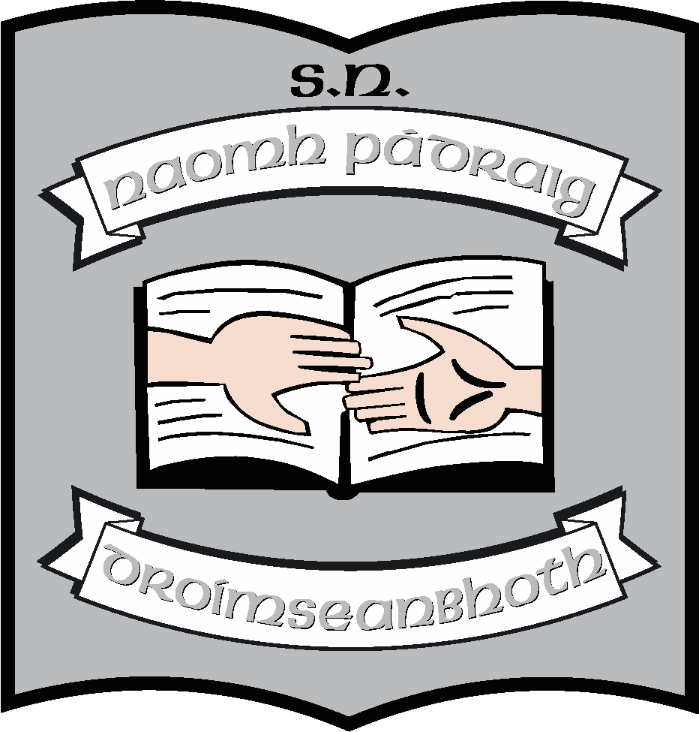

Agreed Report of Board of Management St. Patrick’s N.S., Drumshanbo, Co. Leitrim.

Meeting date: 24/09/2024

- Ruth read a letter from Michael D. Higgins to the BOM wishing us well for our 50th birthday.

- The Board of Management ratified the following policies at the meeting:
- Anti-Bullying Policy 2024
- Child Protection Policy 2024
- Child Safeguarding Statement 2024
- Child Safeguarding Risk Assessment 2024
- Posts of Responsibility
- SEN Policy 2024-2025
- Working Together Document

- The Principal’s report read by Ruth had the following topics:
- Staffing presented for the year, see website for the full list.
- A report was received from Peter O’Sullivan, Occupational Therapist, following an assessment he made of our school. We have made an initial application to the Department of Education seeking grants for equipment for children with special educational needs.
- We agreed on the proposed drawings for the new classrooms/storage at the back of the school. We agreed to the drawings for the Sports’ Facility behind the school also. These will go for planning in the next few weeks.
- The school’s 50th Birthday will be celebrated on Friday the 25th and Saturday 26th of October. The parents and the wider community have been informed of upcoming events. Ruth praised the staff for their efforts in relation to the schools’ upcoming birthday celebrations.
- We are very thankful to the staff of Abbotts Longford, who came to our school in August, as part of their wellbeing initiative. They done trojan work around the school grounds which included painting and weeding.
- Ruth thanked Daniel Szyma for his voluntary work painting the school over the summer holidays. Ruth also acknowledged Terri Mc Gourty for all her work in the sensory garden.
- The Parents Association have kindly offered to do party bags for the children in the school for the 50th birthday celebrations. They have agreed to help supplement our Christmas trips to the Panto and the Dock. Cash for Clobber dates have also been arranged for the Saturday the 19th of October and Saturday the 2nd of November. The Parent’s Association have asked us to conduct a survey on Aladdin regarding hot lunches at school.

This concluded the meeting of St. Patrick’s N.S. Board of Management.
Signed:

Martin McGowan Ruth McLoughlin
________________________________________________________________

Martin McGowan Ruth McLoughlin
Chairperson Principal

