|  |
| --- |
| **St. Patrick’s National School. Roll No. 19423J**    **Drumshanbo, Co. Leitrim**  **Tel: 071 96 41755**  **Email: stpatricksnsdrumshanbo@gmail.com**  **Website: stpatricksnsdrumshanbo.ie** |

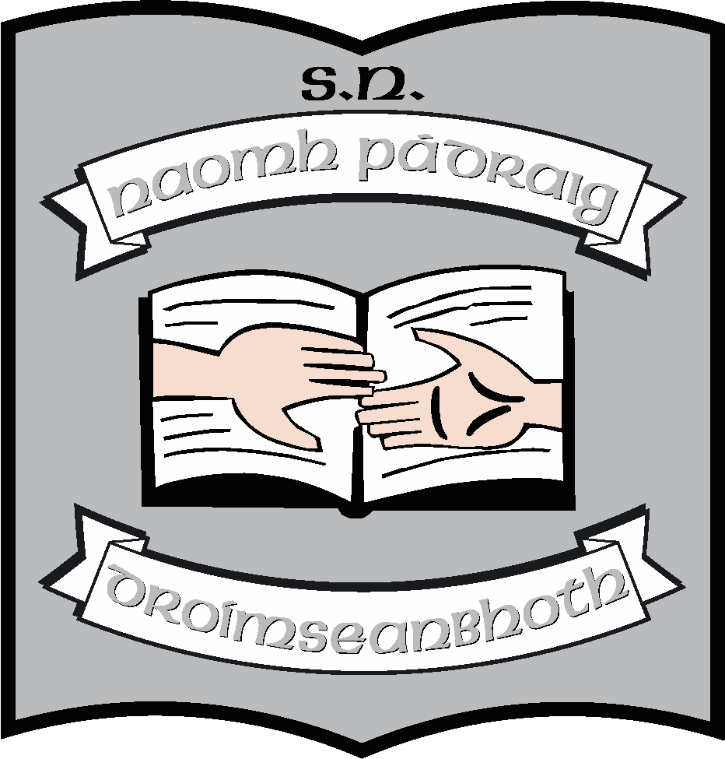

4th June, 2024.

Dear Parent(s)/Guardian(s),

Book lists for 2024 – 2025 will go up onto the school website shortly. We can send home a hard copy if you wish, just email the school. We operate a book rental scheme as we have done for years. The Dept. of Education are continuing with the “free schoolbooks” for all children in primary schools albeit they have reduced the amount per child that they are paying. The grant will go towards the purchase of books and copybooks. If you look at the booklist for your child, we have tried to include everything they will need. All schoolbooks remain the property of the school and are on loan to pupils. Pupils will retain books for one school year and return to the school, in good condition, at the end of the year.

There are items on the booklists however, under the heading “other requisites” which are not covered under the scheme and for which we must seek payment. These include photocopying, art & craft, standardised tests, and homework notebooks. (Photocopying paper has doubled in price, our learning platform “Seesaw” as well as Alpaca, our early literacy assessment tool used in the junior end of the school comes at a price as does Aladdin, our communication platform).

**Taking all this into account, we are holding the price at €50 per child again this year.**

We can take cash payments, but, for reasons of security, we would prefer that you make all payments electronically.

When you pay electronically you will need to

* Log in to your online banking.
* Set the school up as a payee using the ADD PAYEE option in the menu. (It will be a SEPA payee).
* The PAYEE NAME is St. Patrick’s NS.
* You will need the school IBAN and BIC codes:
* **IBAN**: IE90 BOFI 9053 8730 4877 88
* **BIC**: BOFIIE2D
* **Please put your child’s name in as a reference so that it will appear on our records and we will know who has made the payment – there is a REFERENCE box in the on screen form**

There is a book form on the back of this letter, we would be grateful if you could return it to us when you are making payment. It might be a good idea to email the school too and put **Payment and your family name** in the subject line of the email.

Thank you, as always, for your help and support.

________________

**Ruth McLoughlin**