St. Patrick’s National School.
Roll No. 19423J

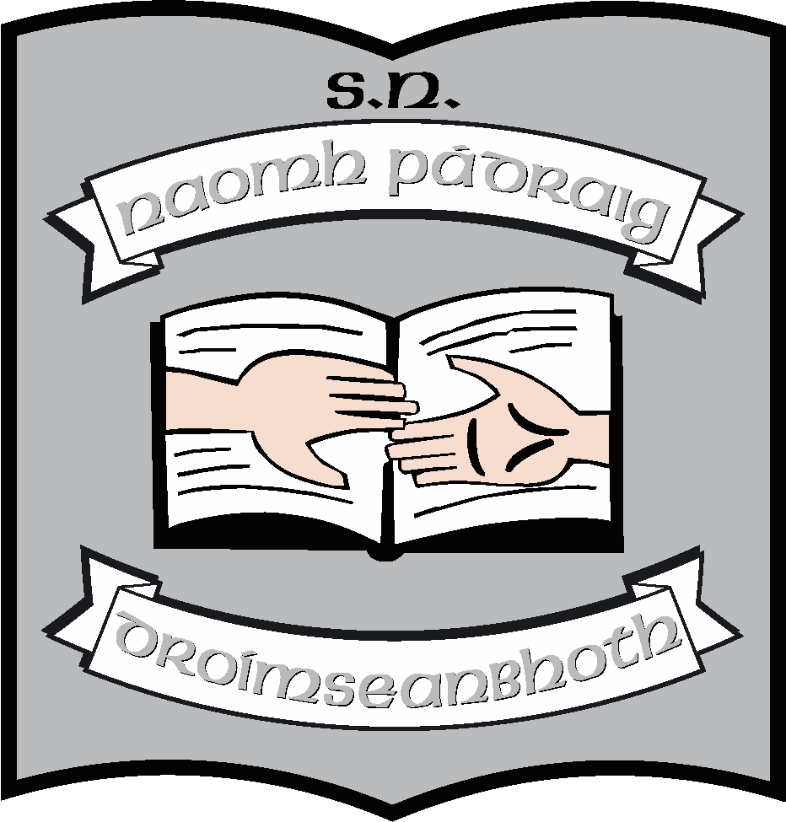

Agreed Report of Board of Management St. Patrick’s N.S., Drumshanbo, Co. Leitrim.

Meeting date: 07/02/2024

- Board discussed quotes for solar panels for the roof which were submitted. Noel took the quotes folder to review.

- Applications for two teacher job shares for the coming school year were accepted.

- Discussion was had regarding the need for a 3rd Autism class. The Board agreed to an application being submitted to the Special Educational Needs Officer for this class.

- The Board of Management ratified the following policies at the meeting:
  - Grievance Procedure Policy
  - Complaints Procedure Policy
  - Parental Status and School Communication Policy
  - Close Circuit Television System Policy
  - Relationships and Sexuality Policy

- Principal’s report read by Ruth had the following topics:
- Current enrolment is 247
- The Parents’ Association raised €5,600 from the Jingle Ball race at Christmas. This will go to fund lots of activities for the children for the coming year. All money raised by the PA is spent directly on the children.
- Following publication from the Department of Special Education Teacher hours, our hours remain the same as the last few years, which is 80 hours per week. We have a visiting teacher shared with Killenummery who comes on Fridays and 3 permanent jobs here in the school.
- Cheque received from Abbots €6,400 for school funds. This will be used to build an outside Aistear Village and sensory equipment for the yard.
- We set up a company for the lease of the new pitch. St. Patrick’s Sports Facility is the company name. Planning is the next necessary step.
- Ruth ordered new signs for the carpark to facilitate reverse parking.
- Permission granted to Ruth to interview SNAs as part of a research project.
- New motorised Stira stairs has been fitted to facilitate easy access to the water tanks in the attic.

This concluded the meeting of St. Patrick’s N.S. Board of Management.

Signed:

Martin McGowan Ruth McLoughlin
________________________________________________________________

Martin McGowan Ruth McLoughlin
Chairperson Principal

