St. Patrick’s National School.
Roll No. 19423J

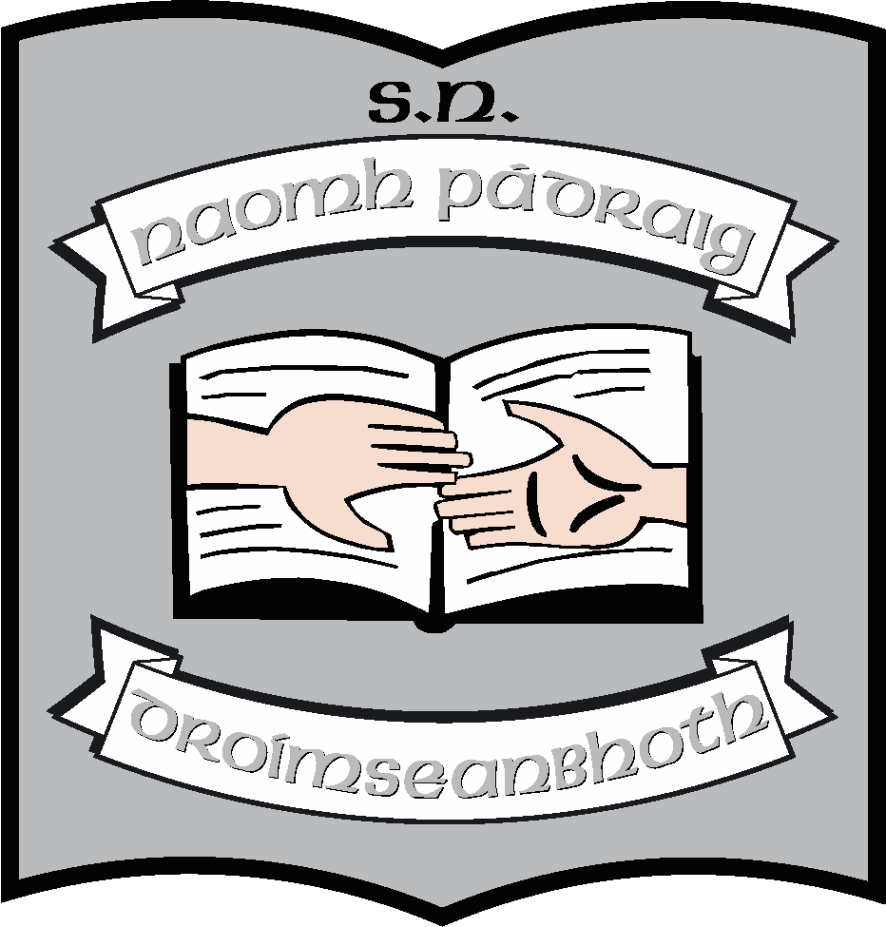

Agreed Report of Board of Management St. Patrick’s N.S., Drumshanbo, Co. Leitrim.

Meeting date: 04/12/2023

- The new board members were welcomed by Martin McGowan (Chairperson). Ruth McLoughlin (Secretary), Maria McGoldrick (Recording Secretary), Aisling MacShera (Treasurer), Noel Heron, Siobhain McGowan, Paul Martin and Fr. Frankie Murray.

- Governance manuals were distributed and forms filled out and forwarded to Diocesan Secretary.

- The Board of Management ratified the following policies at the meeting:
- Special Education Needs Policy 2023
- School Strategic Plan
- School Evaluation and School Improvement Plan

- Principal’s report read by Ruth had the following topics:
- Ruth thanked the outgoing BOM for their commitment and dedication over the past 8 years.
- Current enrolment is 248
- New Parents’ Association has been initiated. Members include; Paul Martin, Siobhain McGowan, Kevin Blessing, Damian Guckian, Thomas Scollan, Rhíona Daly, Ciara Flynn and Edel Spark. Their future fundraisers were highlighted to the Board.
- Permission granted to lease the field from the Diocese. Orla Walsh, Ruth and Fr. Frankie attended meeting in Longford with the Diocesan Trust.
- Cheque for €4,000 received from Tony McGowan run committee.

This concluded the meeting of St. Patrick’s N.S. Board of Management.

Signed:

Martin McGowan Ruth McLoughlin
________________________________________________________________

Martin McGowan Ruth McLoughlin
Chairperson Principal

