St. Patrick’s National School.
Roll No. 19423J

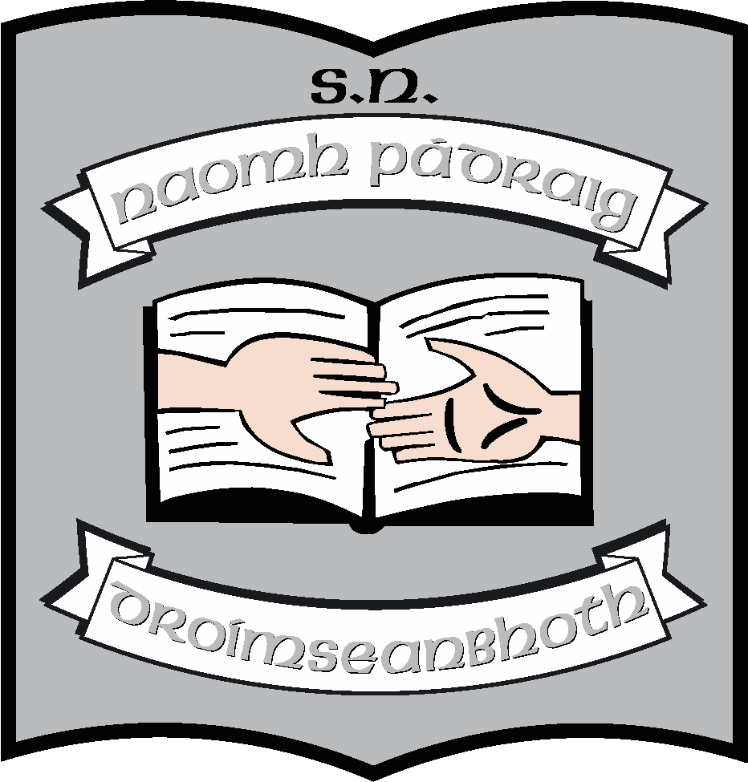

Agreed Report of Board of Management St. Patrick’s N.S., Drumshanbo, Co. Leitrim.

Meeting date: 27/05/2024

- Board ratified two teachers for maternity leaves. These are;
- Evan Sweeney
- Martina Gallagher

- The Board of Management ratified two new permanent SNA posts for the new Autism class. They are;
- Caolann Scolann
- Sinéad Dolan

- Job share between Jeannette Reynolds and Stephanie Reynolds was also approved.
- Ruth reported that our new Solar panels were installed and connected. They are fully operational.
- Ruth informed the meeting that we are in the process of applying for planning permission for the new all-weather pitch.
- Class teachers were announced for the coming year and parents will be informed when booklists are released in a few days.
- Ruth informed the meeting that the school would be used for polling at the local and European elections on Friday 7th June.
- Staff meeting will take place on Wednesday June 5th from 2pm to 4pm. Parents have been notified.
- Ruth requested the boards permission to seek advise from a specialist occupational therapist, who might make recommendations for equipment for children with additional needs. This was sanctioned by the board.

This concluded the meeting of St. Patrick’s N.S. Board of Management.

Signed:

Martin McGowan Ruth McLoughlin
________________________________________________________________

Martin McGowan Ruth McLoughlin
Chairperson Principal

