St. Patrick’s National School.
Roll No. 19423J
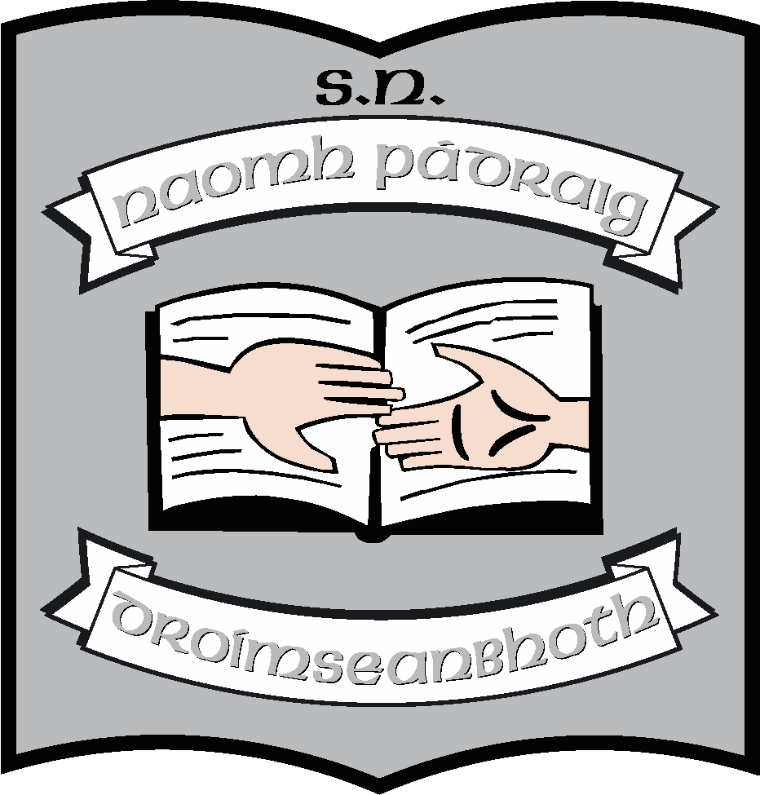
Drumshanbo, Co. Leitrim
Tel: 071 96 41755
Email: stpatricksnsdrumshanbo@gmail.com

School Uniform
The school uniform is comprised of
- Grey trousers/skirt/pinafore
- White shirt/polo shirt/blouse
- V-necked wine jumper/cardigan

Every child must have this uniform for general school use. It is also the uniform that children would be asked to wear on special occasions when representing the school. These items may be purchased in any shop where available.
Crested jumpers can be bought in The Magnet in Carrick-on-Shannon, but it is not compulsory to have a crested jumper.
There is a school track-suit (available in The Magnet in Carrick-on-Shannon) which can also be worn as school uniform, especially on days when children have PE or sporting activities. However, parents are not obliged to buy it.

Note:
- Children should have comfortable shoes/runners.
- We recommend that long hair is kept tied up.
- We do not allow drop down earrings for health and safety reasons

