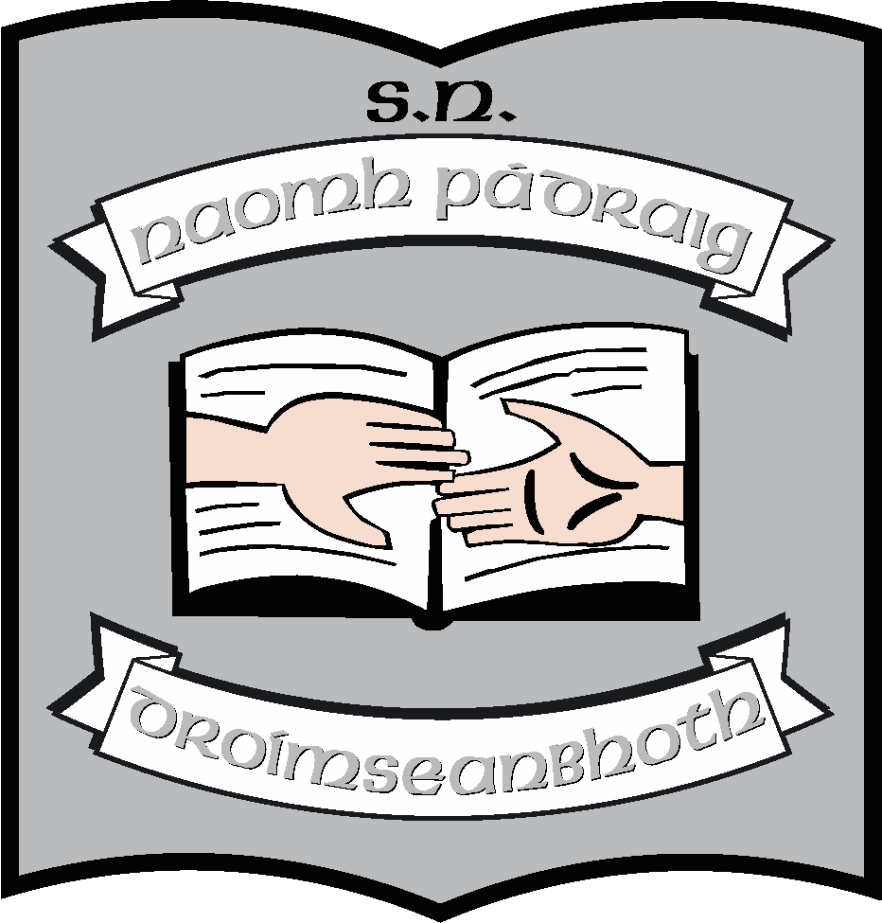

Annual Report of the Board of Management of St. Patrick’s NS
2015 - 2016
The Board of Management of St. Patrick’s NS consists of
- Martin McGowan (Chairperson & Bishop’s Representative)
- Fr. Frankie Murray(Bishop’s Representative)
- Aisling Fee (Parents’ Representative & Treasurer)
- Pascal Gillard (Parents’ Representative & Safety Officer)
- Stella Kehoe (Community Representative)
- Enda mcGloin (Community representative)
- Regina McLoughlin (Teachers’ Representative & Recording Secretary)
- Máirín O’Keeffe (Teachers’ Representative & Secretary)

Meetings
During this school year, the board had scheduled termly meetings in September, October, December, March and June. It also met in August to ratify the appointment of Samantha Cullen as an SNA in the school.
School Self-evaluation (SSE)
School self-evaluation was undertaken in the area of Gaeilge – léitheoireacht agus scríbhneoireacht (reading and writing) but was suspended due to industrial action in all schools.
We also undertook an evaluation process with regard to Catholic Schools’ Partnership. This was led by Regina McLoughlin and involved Fr. Frankie, the teaching staff and a number of parents.
Policy
The following organisational policies were reviewed during this school year and have been uploaded onto the website.
- Child Protection
- Healthy Eating Policy
- Anti-Bullying Policy
- ICT Policy
- Attendance Policy
- Special Educational Needs Policy
- Work experience Policy
- Enrolment Policy for Autism Class

The following curricular policies were reviewed
- History Policy
- English Policy - writing
- Drama Policy
- PE Policy

Maintenance
Outside of regular school maintenance, the board undertook the following
- A resource and storage room was created by shelving one of the portacabins.
- Two sink press units are being replaced in the classrooms over the summer.
- Improvements in the garden especially at the front of the school where work was carried out at the entrance area as well as the replacement of the hanging baskets.

Resources
- Two data projectors were replaced; one lap-top was replaced; these are for use with the interactive whiteboards in the class room.
- New electronic piano purchased

Other
The Board was involved supporting and funding some of the events which took place in regard to the 1916 commemorations and the events and activities which formed part of our successful application for Active School status.
The Board would like to thank the school community for its support during the year. We would particularly like to thank the Parents’ Association for its commitment to the pupils in the school. They have supported Gymnastics, Swimming, Horse-riding, Graduation events to name but a few. The Board would also like to thank all parents for their ongoing support for the work of the school and for the well-being of the children.
June 2016

