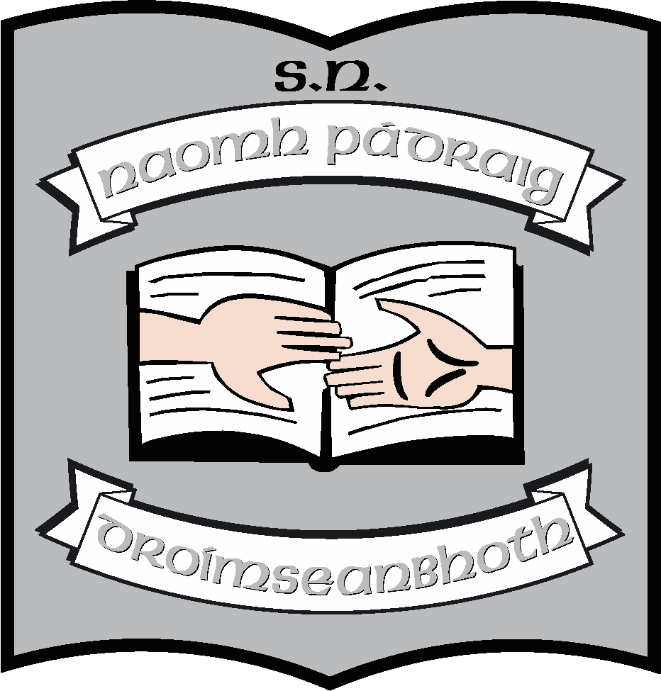

Annual Report of the Board of Management of St. Patrick’s NS
2014 - 2015
The Board of Management of St. Patrick’s NS consists of
- Martin McGowan (Chairperson & Bishop’s Representative)
- Fr. Peter Burke (Bishop’s Representative)
- Christiane Gunning (Parents’ Representative)
- John Casey (Parents’ Representative & Safety Officer)
- Maisie Fee (Community Representative & Treasurer)
- Michael McKenna (Community representative)
- Clare McLoughlin (Teachers’ Representative & Recording Secretary)
- Máirín O’Keeffe (Teachers’ representative & Secretary)

Meetings
During this school year, the board had scheduled termly meetings in September, November, February and May. It also met in March in preparation for the WSE (Whole School Evaluation). It will meet again when the WSE report is published, to consider the findings of the WSE and to make a response to those findings.
School Self-evaluation (SSE)
School self-evaluation was undertaken in the area of literacy and a report was published on the school web-site. A four year School Improvement Plan for literacy was drawn up and published. The school has completed year 2 of the numeracy plan which was published in June of last year.
Policy
The following organisational policies were reviewed during this school year and have been uploaded onto the website.
- Child Protection
- Enrolment Policy
- Anti-Bullying Policy
- Critical Incident Policy
- Attendance Policy
- Learning Support
- Mobile Phone Policy
- AUP Policy ( Acceptable Use Policy – Internet)
- Supervision Policy
- Tours Policy
- Homework Policy
- RSE
- Assessment
- Class and classroom allocation
- Substance abuse
- Administration of medicines Policy
- SNA Policy
- Data Protection and record retention Policy
- Parental Involvement Policy

The following curricular policies were reviewed
- Science Policy
- English Policy
- Visual Arts Policy
- SPHE Policy

Maintenance
Outside of regular school maintenance, the board undertook the following
- The purchase of the two portacabins which has previously been rented; these will be uses to store school resources and as resource rooms. They will be shelved during the summer.
- The purchase of a storage unit for PE equipment
- The refurbishment of the hall
- Improvements in the garden including the development of a sensory garden with planters and access for the autism class

Resources
- The purchase of PE equipment including mats and benches as well as general equipment in sufficient quantities for class teaching.
- The creation of a sensory room.
- Purchase of 10 lap-tops(Notebooks) for pupil use in September 2015 & 1 replacement lap-top for teacher
- Purchase of reading resources to facilitate Literacy Lift-Off and Guided Reading programmes in the school from September 2015 (See School Improvement Plan for literacy on stpatricksnsdrumshanbo.scoilnet.ie/schoolpolicies)

Other
The Board was involved in preparation for the Whole School Inspection which took place in April.
The Board would like to thank the school community for its support during the year. We would particularly like to thank the Parents’ Association for its ongoing commitment to the pupils in the school.
May 2015

